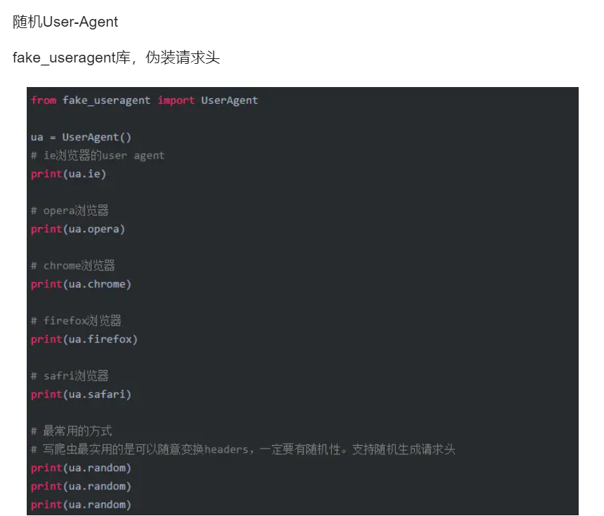

<https://blog.csdn.net/qq_43652321/article/details/107606571>